

NEOCMS

Church Management system



February 20, 2025

nEO tECHNOLOGIES

Ruai, Bypass

A **Church Management System (CMS)** is a software application designed to help churches efficiently manage their daily operations, including member records, events, finances, and communications. Below are the key functions of a church management system:

The following features are part of the Church Management System suite:

The **Membership Management:** The application offers a diverse function to enable church to store member information, create new profiles, and update existing ones. Tracks member attendance, donations, and participation in church activities. Enables segmentation of members into groups (e.g., choir, youth ministry, elders).

The **Event and Service Management (Inventory Management):** The application Schedules and manages church services, events, and programs. Tracks attendance and volunteer assignments. Enables resource allocation for different church activities.

The **Financial and Accounting Module:** The application operations report to a robust accounting and finance that enables the church to store their general financial reports. This system allows churches to generates financial reports such as expense tracking, charts of account and invoices and receivables (e.g., pledges, donations, projects).

The **User Access Control:** This application part restricts system access based on user roles (e.g., pastor, treasurer, administrator). Ensures sensitive financial and member information is protected.

Contents

Marks Indication 2

**LAUNCHING** 3

**CHAPTER 1 DASHBOARD** 4

**CHAPTER 2 MEMBERS CREATION** 4

1) All Members 4

2) Categories 7

a) Families 7

b) Children 9

c) Visitors 11

3) Preachers 13

4) Church Groupings 15

5) Leaderships 18

6) Members Settings 21

**CHAPTER 3 ACCOUNTING** 25

1. Set up 25

a) Currency 25

b) Cash Books 26

c) Chats of Accounts 27

c) Financial Periods 31

2. Transactions 31

a) Post Transactions 31

b) Post expenses 34

c) Pay Expenses 35

d) Expenses data 37

3. Givings (Collections) 37

a) Pledges 37

**Chapter 5 PROFILE** 41

a) Profile creation 41

# Marks Indication

1. Buttons Indicated in **BLUE** square(**blue** writing)
2. Icons Indicated in **BLACK** square (**brown** writing)
3. Fields boxes indicated in **GREEN** square (**black** writing)
4. Dialog popups and confirmation indicated in **PURPLE** square (**red** writing)

# **LAUNCHING**

To launch the Church Management System. Do this to navigate to

**>> Neo CMS (on the desktop)**

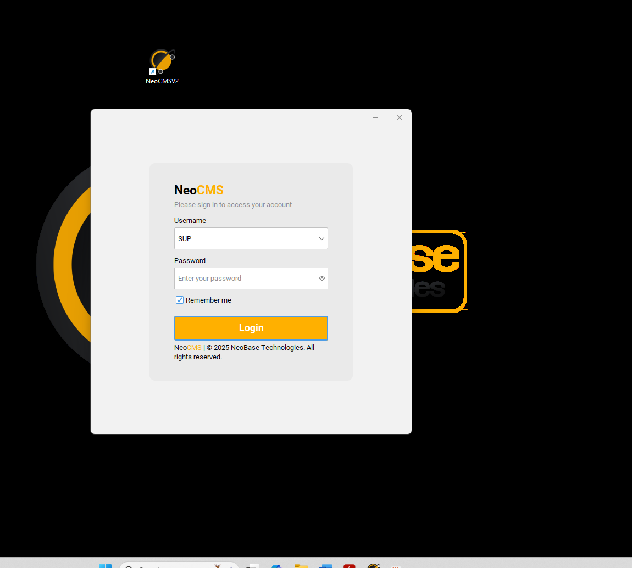

AR 2

**AR 1**

AR 3

AR 4

AR 4

* Run Neo CMS from your desktop **AR1**
* On the window that appears select the Username from the list **AR2**
* Enter the password **AR3**
* Click on Login Button **AR4**

# **CHAPTER 1 DASHBOARD**

The dashboard contains the overall Church analysis, Total balance of contributed money, Total income, Total church expenses, Gender analysis, Latest 4 transactions made in the system and finally the calendar for event post.

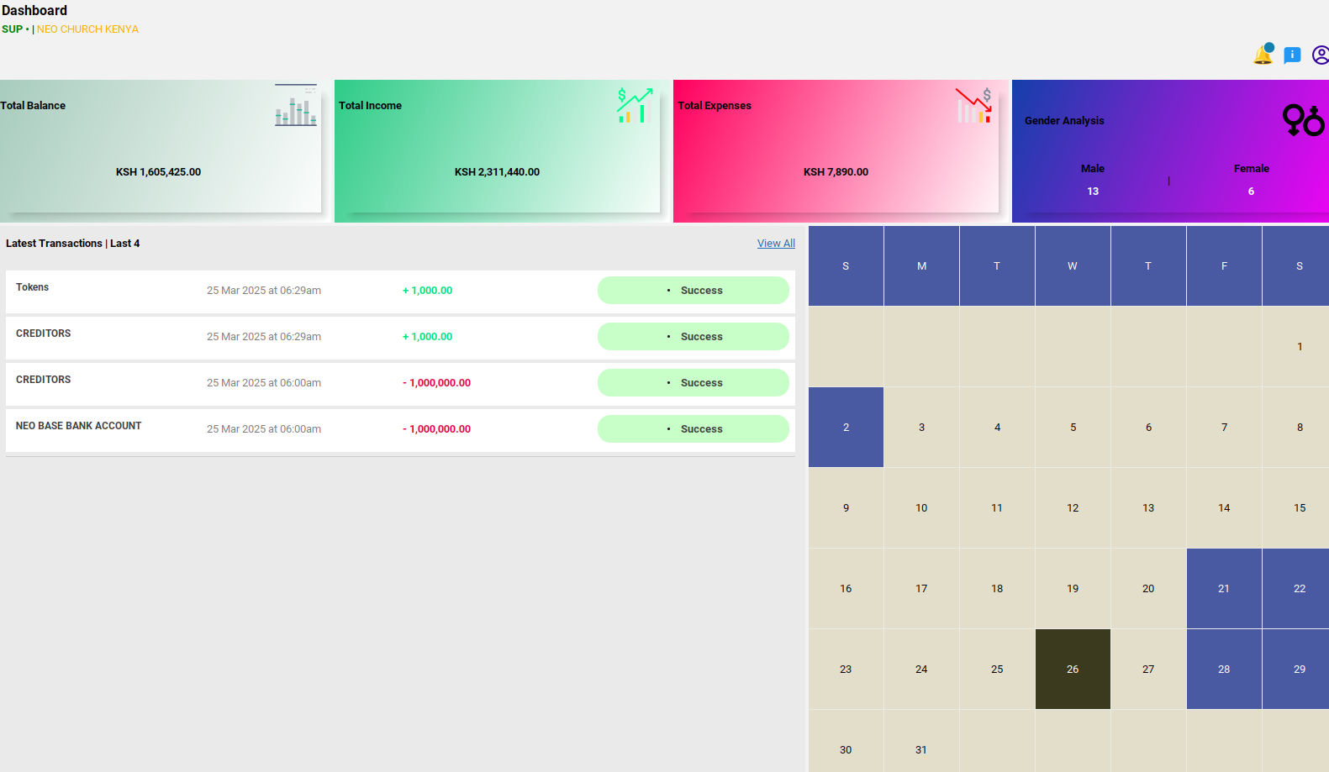

# **CHAPTER 2 MEMBERS CREATION**

## All Members

This part records all the members in the church

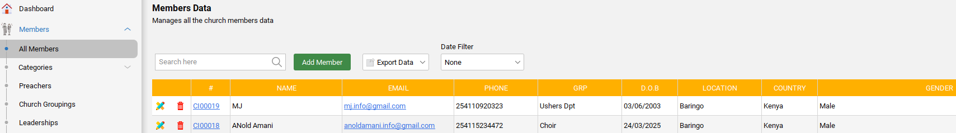

**AR** **3**

**AR** **2**

**AR** **1**

* Under All Members **AR1**
* **AR2** is the search panel that allows you to search a member in the table
* Click on Add member button **AR3** (Displays a panel **AR4**)

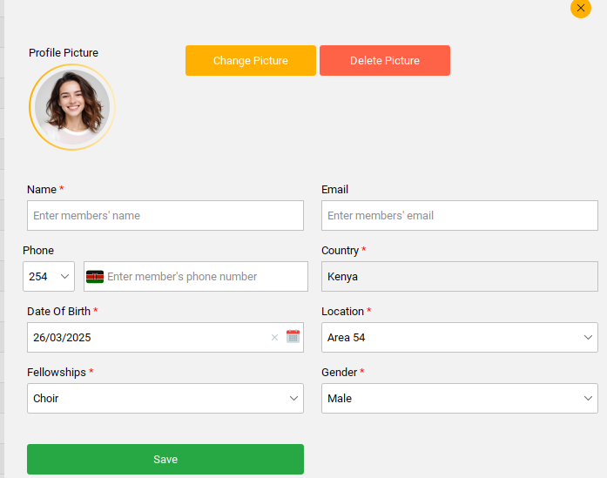

**AR** 4

**AR** **5**

**AR** **6**

**AR** **7**

**AR** **8**

**AR** **9** 9

**AR** **10**

**AR** **11**

**AR** **12**

**AR** **15**

* Enter Name **AR5**
* Enter Phone details **AR6**
* Enter Date of Birth **AR7**
* Enter Fellowship by choosing the group the member belongs to from the dropdown **AR8**
* Enter Email **AR9**
* Enter Country **AR10**
* Enter Location where the member is or is stated **AR11**
* Enter Gender choose from the dropdown **AR12**

**>>>To add, change or delete the profile;**

* Click on Change profile button **AR13** (Takes you to the Home page window (Image Upload) choose the picture to add, save.
* To delete the profile, click on delete picture button **AR14**
* Click on Save button **AR15**



**AR** **13**

**AR** **14**

**AR** **15**

* Keep adding the members to save in the table

**>>>To update the member details**

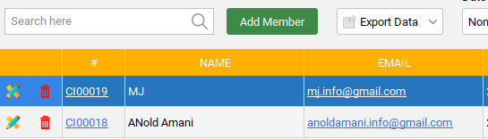

**AR** **1**

* Click **AR1** edit icon(Displays the dialog pops to allow you update the member).
* Click on Update button to update the member details

**>>>To delete a member**

* Click **AR1** delete icon **(**A confirmation message **AR2** to delete pops up click Yes to delete or No to retain the data)

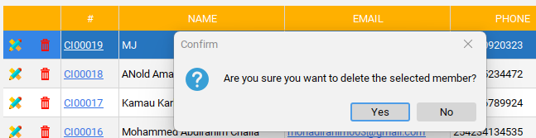

**AR** **2**

**AR** **1**

Under members one can Export data through PDF or Excel **AR1** and also Filter data **AR2**

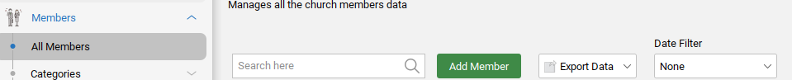

**AR** **1**

**AR** **2**

## Categories

Under categories we have the following submenus;

### Families

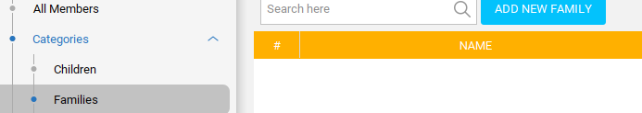

**AR** **1**

**AR** **2**

**>>>To add a family to the church data;**

* Click on Families **AR1**
* Click Add new family button **AR2** (A form dialog **AR3** is displayed)

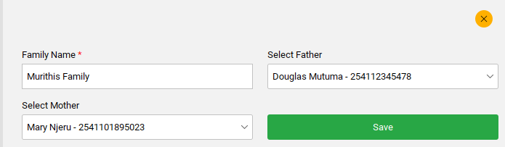

**AR** **3**

**AR** **4**

**AR** **6**

**AR** **5**

**AR** **7**

* Enter Family name **AR4**
* Select mother **AR5** from the drop down
* Select Father **AR6** from the drop down
* Click on Save button **AR7** to save the family added a form confirmation pops up to confirm

After saving, the details should be displayed in a table as shown in **AR9**;

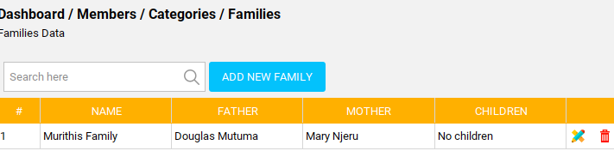

**AR** **9**

**>>>To edit a family member;**

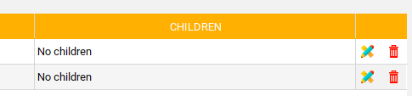

**AR** **1**

* Click **AR1** edit icon (A form dialog pops to enable editing and updating the existing family data)
* Click update button to update family data

**>>>To delete a family data;**



**AR** **1**

* Click **AR1** delete icon (A confirmation message pops for confirmation)

### Children

Under categories on Children;

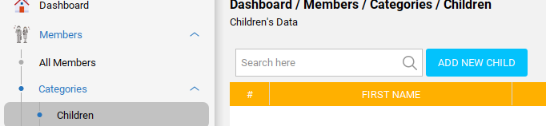

**AR** **1**

**AR** **2**

* Click Children **AR1**
* Go to Add new child button **AR2** and click (Displays a form **AR3** to add details of the child)

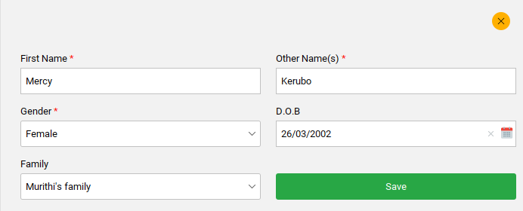

**AR** **3**

**AR** **4**

**AR** **6**

**AR 7**

**AR** **5**

**AR** **8**

**AR** **9**

* Enter First name **AR4**
* Enter other name **AR5**
* Enter Gender **AR6** from the dropdown
* Enter family **AR7** (this contains the name of the family the child belongs to)
* Add child Date of birth **AR8**
* Click save button **AR9(**A form confirmation pops for confirmation)

After saving the, the data should be saved in a table as shown;

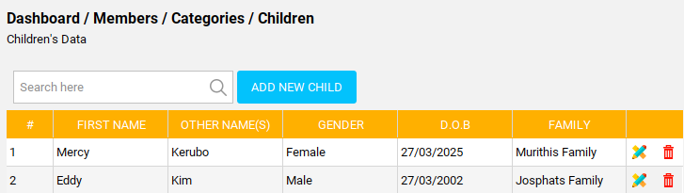

**>>>To edit the child data**

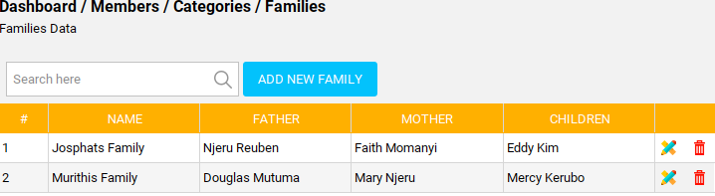

**AR** **1**

* Click **AR1** edit icon **(**A form dialog with the existing child data pops to allow edit and update)
* Click save button to save

**>>>To delete**

* Click **AR1** delete icon (Displays a confirmation pop up **AR2** for confirmation)

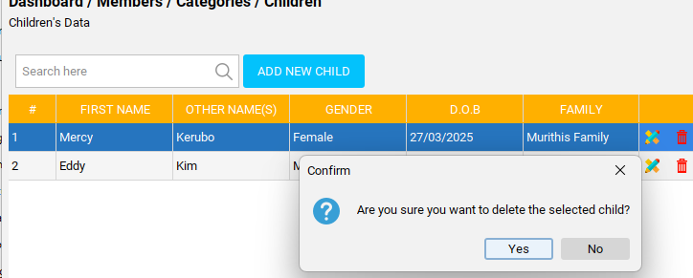

**AR** **1**

**AR** **2**

### Visitors

This is where all visitors are recorded

**>>>To add a visitor**

* Click **AR1**

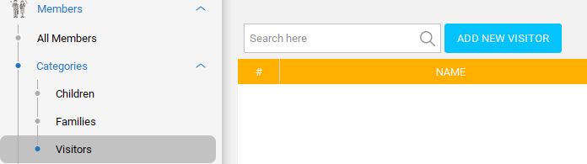

**AR** **1**

**AR** **2**

* Go to Add new visitor button **AR2**(A form dialog **AR3** pops to allow adding visitor details

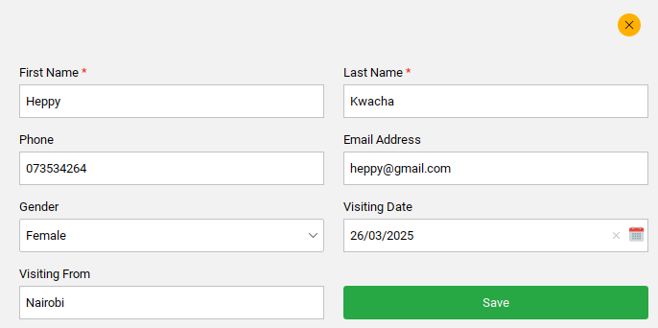

**AR 3**

**AR** **4**

**AR** **6**

**AR** **8**

**AR** **5**

**AR** **7**

**AR** **9**

**AR 11** **11**

**AR** **10**

* Enter first name **AR4**
* Enter last name **AR5**
* Enter phone number **AR6**
* Enter email address **AR7**
* Enter gender chosen from the dropdown list **AR8**
* Enter visiting date when the visitor visited **AR9**
* Enter the location where the visitor is originating from **AR10**
* Click save button **AR11**

The visitor data should save in the table as shown

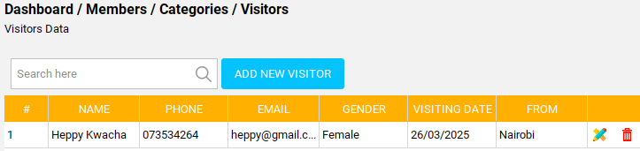

**>>>To edit the existing visitor detail**

* Click **AR1** editicon (A form dialog pops to allow editing of the existing visitor details)



**AR** **1**

* Click save button to save changes

**>>>To delete a visitor data**

* Click **AR1** delete icon (A form dialog **AR2** pops for delete confirmation)

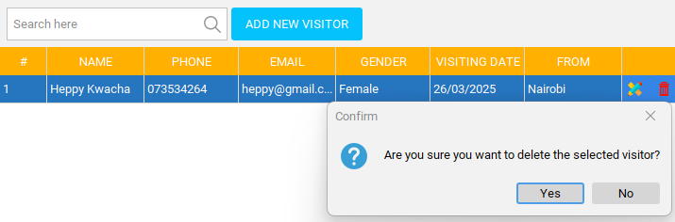

**AR** **1**

**AR** **2**

## Preachers

This is the area where all preachers’ data is added.

**>>>To add a preacher**

* Click **AR1**

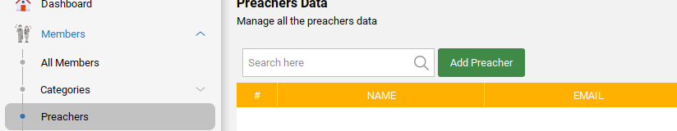

**AR** **1**

**AR** **2**

* Go to Add preacher button **AR2**(A form dialog **AR3** pops to add adding the preacher details
* Enter preacher name **AR4**
* Enter phone number **AR5**
* Enter location from which the preacher come **AR6**
* Enter the email **AR7**
* Enter the country **AR8**
* Enter the gender from the given dropdown **AR9**
* Under notes **AR10** describes little bit about the preacher but its optional
* Click save button **AR11**(A form dialog pops for save confirmation)

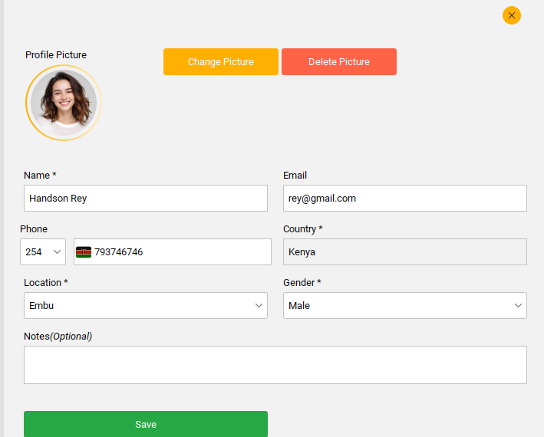

**AR** **3**

**AR** **4**

**AR** **5**

**AR 6**

**AR** **10**

**AR** **7**

**AR** **8**

**AR 9**

**AR** **11**

**AR** **12**

**AR** **13**

**>>>To change, add or delete a profile picture**

* Click change picture button **AR12**
* To delete click, delete picture button **AR13**

Save the data to save in the table as shown below.

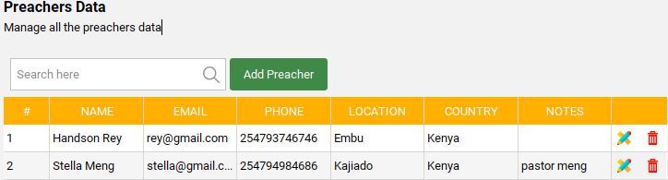

**>>>To edit the existing pastor data;**

* Click **AR1** edit icon

**AR 1**

* A form dialog with the existing pastor detail pops to allow editing
* Click update button to update preachers’ data

**>>>To delete a preacher**

* Click delete icon **AR1**(A delete confirmation **AR2** pops up to confirm deletion)

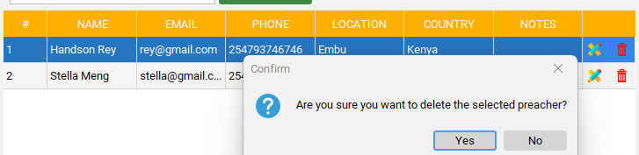

**AR** **1**

**AR** **2**

## Church Groupings

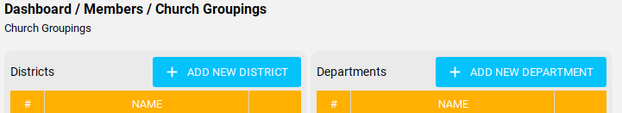

This section contains two parts; **the district** (place to add the district location of the church branches) and **the department** (place to record all departments that are available in the church e.g. choir department, women fellowships, men fellowships, Sunday school etc.

**>>>In the district section shown below;**

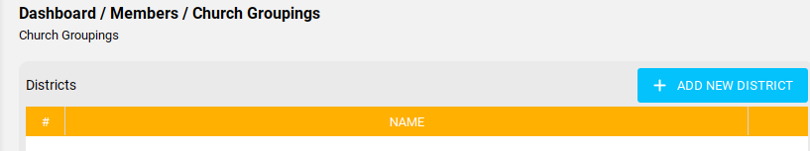

**AR 1**

* Click Add new district button **AR1**(A form dialog **AR2** pops to allow adding the church district location)

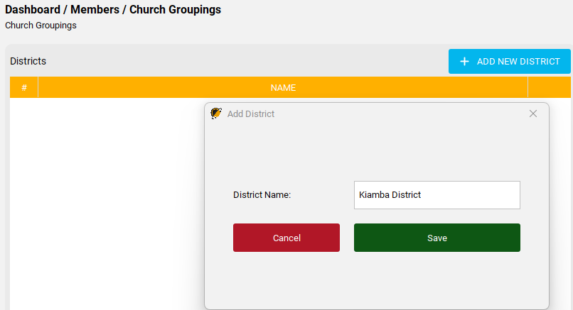

**AR** **2**

**AR 3**

**AR 4**

**AR 5**

* Enter church district **AR3**
* Click save button **AR4** to save the district name
* Click cancel button **AR5** if you want to cancel the district or add another different

When you click save button **AR4** a confirmation dialog should pop for save confirmation

**>>>To edit the existing district if maybe you want to change the name**

* Click edit icon **AR1**

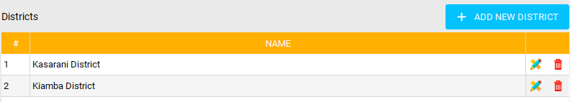

**AR 1**

A form dialog pops to allow you to edit or make changes

* Click update button to update after making changes

**>>>To delete a district**

* Click delete icon **AR1**(A confirmation dialog **AR2** pops up to confirm deletion)

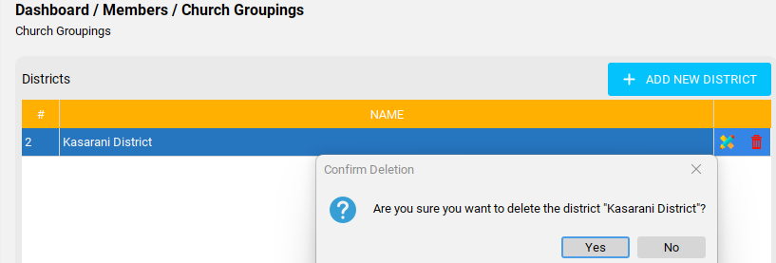

**AR 1**

**AR 2**

**>>>In the department section shown below;**



**AR 1**

* Click add new department button **AR1**(A form dialog **AR2** pops to allow you to add a church department)

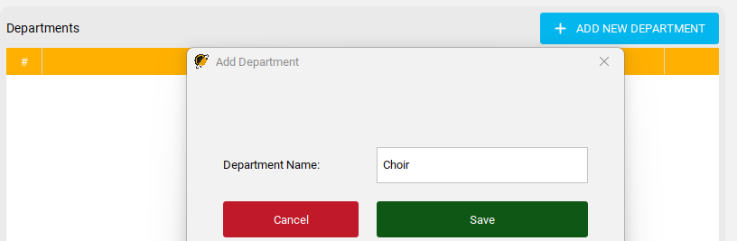

**AR 4**

**AR** **2**

**AR 3**

**AR 6**

* Add department **AR3**
* Save button **AR4**(A confirmation dialog pops for confirmation)
* Click cancel button **AR6** if you want to cancel the department

Save the data to fill in the table as shown below;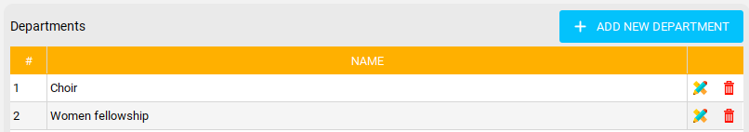

**>>>To edit a department in the table;**

* Click edit icon **AR1**(A form dialog **AR2** pops to allow you to edit the department)

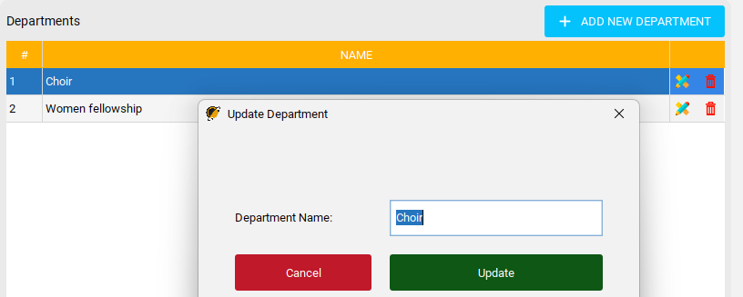

**AR 1**

**AR 2**

**AR 4**

**AR 3**

* Click update button **AR4**

**>>>To delete a department;**

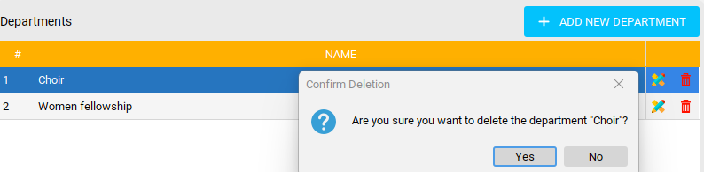

**AR 2**

**AR 1**

* Click delete icon **AR1**(A confirmation dialog **AR2** pops to confirm deletion)

## Leaderships

This section records data of all leaders in the churches

* Click under Leaderships **AR1**

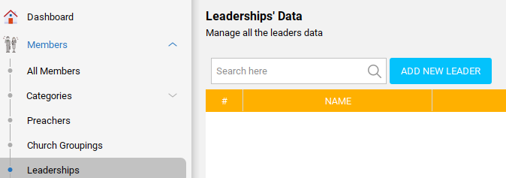

**AR 1**

**AR 2**

* Navigate to add new leader **AR2**(A form dialog **AR3** pops to allow you to add a leader details)
* Enter a leader name **AR4** from the dropdown (the names in the dropdown comes from the members name added from the start)
* Select type **AR5**(The types originate from the created leadership role)
* Under district **AR6** add the district location of the church the leader is (the district from the dropdown originates from church groupings added district

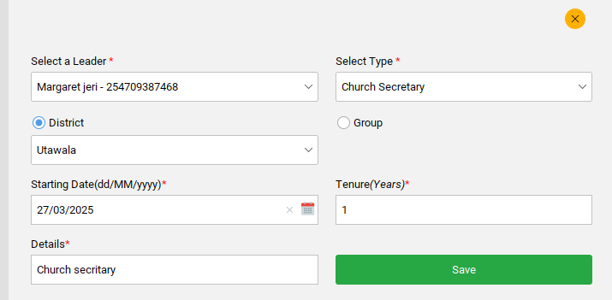

**AR 4**

**AR 3**

**AR 5**

**AR 6**

**AR 7**

**AR 8**

**AR 9**

**AR 10**

* Enter the starting date **AR7** for which the leader will begin his/her role
* Enter years **AR8** the duration the leader will have on the position
* Enter details **AR9** indicate anything in this area a note or a summary
* Click save button **AR10**

Save the data to fill in the table as shown below;

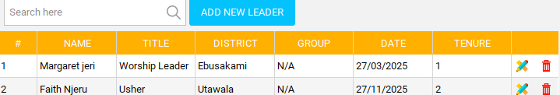

In the same dialog **AR3** shown below;

In this section you can select the group section which are the departments in the church the leader is currently in

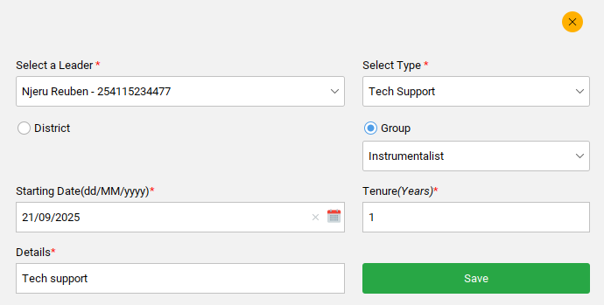

**AR 1**

* Click on group **AR1** to allow you access to choose the department the leader belongs to then fill the rest of the form and save

The table after saving appears to fill the department in the group column **AR1** as shown below compared to the data saved when selecting district **AR2**;

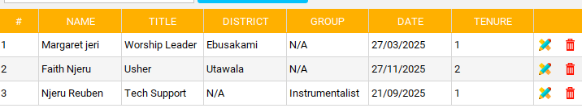

**AR 1**

**AR 2**

**>>>To edit a leader**



**AR 1**

* Click edit icon **AR1**(A dialog pops to allow editing) Edit the form and proceed to click save button

**>>>To delete a leader data**

* Click delete icon **AR1**(A dialog for delete confirmation **AR2** pops to confirm)

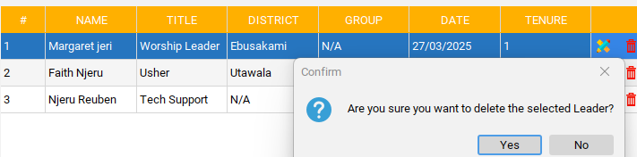

**AR** **1**

**AR 2**

## Members Settings

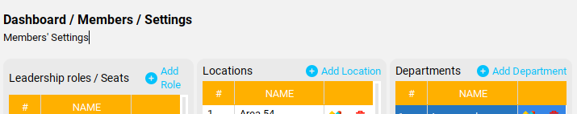

This section is where you record the leadership roles / seats in the church, the location of the churches e.g. branches, main church and departments contained I the church.

Take you to the following;

**>>>Under leadership roles /seat**

* Click add role **AR1**(A form dialog pops **AR2** to allow you to add a role)

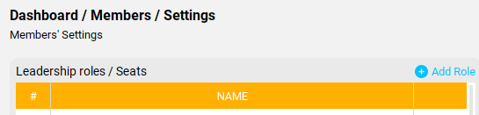

**AR 1**

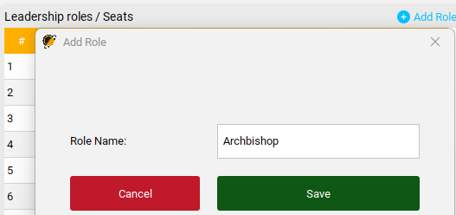

**AR 3**

**AR 2**

**AR 4**

**AR 5**

* Enter the role name **AR3**
* Click save button **AR4** to save or
* Click cancel button **AR5** to cancel the role

**>>>To edit a role**

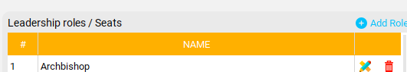

**AR 1**

* Click edit icon **AR1**(A dialog pops to allow editing) Click update button or click cancel button if you want to cancel the edit

**>>>To delete a role**



**AR 1**

* Click delete icon **AR1**(A dialog pops for delete confirmation)

**>>>Under Location**

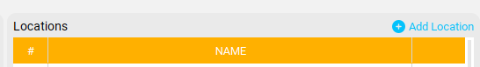

**AR 1**

* Click add location button **AR1**(A dialog pops **AR2** to allow you to add a location)

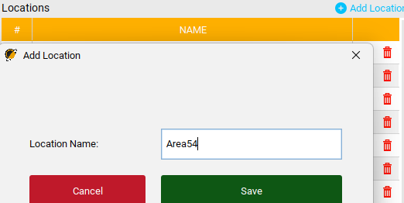

**AR 2**

**AR 3**

**AR 4**

**AR 5**

* Enter the location of the church **AR3**
* Click save button **AR5** or
* Click cancel button **AR4** if you want to cancel

**>>>To edit location**

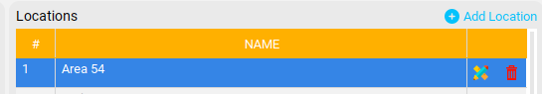

**AR 1**

* Click edit icon **AR1**(A form dialog pops to allow editing) Edit the location and click update button to save changes

**>>>To delete a location**



**AR 1**

* Click delete icon **AR1**(A dialog pops to confirm deletion)

**>>>Under departments**



**AR 1**

* Click add department **AR1**(A form dialog **AR2** pops to allow you to add a department)

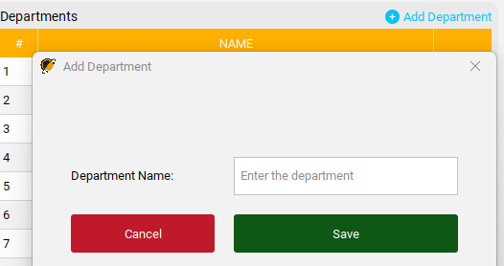

**AR 5**

**AR 2**

**AR 3**

**AR 4**

* Enter department name **AR3**
* Click save button **AR4**
* Click cancel button **AR5** if you want to cancel

**>>>To edit a department**

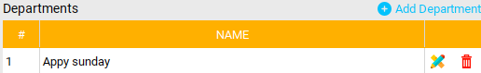

**AR 1**

* Click edit icon **AR1**(A form dialog pops to allow editing) Edit the form and click update button to save changes

**>>>To delete a department**



**AR 1**

* Click **AR1**(A confirmation dialog pops to confirm deletion)

# **CHAPTER 3 ACCOUNTING**

This section of the system is the core center. This part will deal with recording all transactions carried out in the church, expenses, project pledges, generation of reports, financial statements and budgeting.

## Set up

**>>>Under Set up**

* Click set up **AR1**

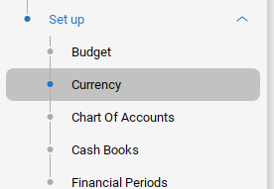

**AR 1**

**AR 2**

### Currency

* Click currency **AR2**
* Proceed to **AR3**

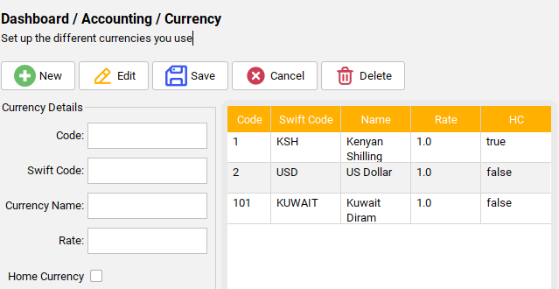

**AR 3**

This section is where we create the currency used in the transactions Kenya shillings, USD etc.

You can **create new currency**, **edit the currency**, **save**, **cancel** or **delete**.

>>>Under currency details

* Enter the **code** this includes digits
* Enter **swift code** this is the currency initials
* **Currency name** is the full currency name
* **Rate**
* Under **home currency** you check true if the currency belongs to your country or false if it’s for another country

### Cash Books

In this section its where you create cash books. Cash books is used to record every transaction involving Cash, Mpesa or Bank.

>>>Under Cashbooks navigate to **AR1**

**AR 1**

**AR 3**

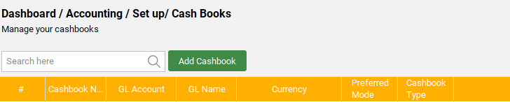

* Click add cashbook **AR3**(A form dialog **AR4** pops to allow you to add a cashbook name)

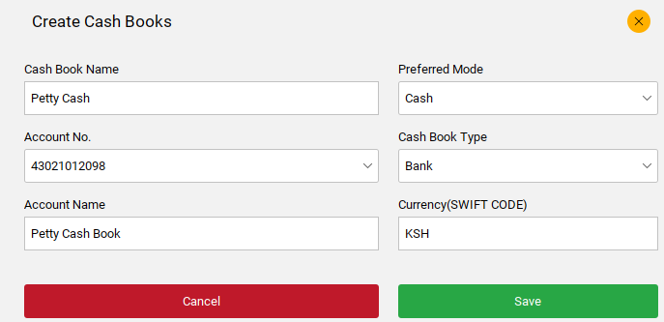

**AR 4**

**AR 5**

**AR 6**

**AR 7**

**AR 8**

**AR 9**

**AR 10**

**AR 11**

**AR 12**

* Enter cash book name **AR5**
* Enter account number **AR6**
* Enter account name **AR7**
* Enter preferred mode from the dropdown **AR8**
* Enter cash book type from the drop down **AR9**
* Enter currency (swift code) **AR10**
* Click save button **AR11**
* Click cancel button **AR12** to cancel cashbook creation

**>>>To edit a cash book**

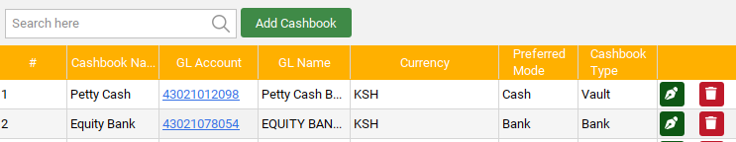

**AR 1**

* Click edit icon **AR1**(A form dialog pops to allow you to edit)
* Edit the cashbook and save changes

**>>>To delete a cashbook**



**AR 1**

* Click delete icon **AR1**(A form dialog pops to confirm deletion)

### c) Chats of Accounts

This section its where you create and manage accounts

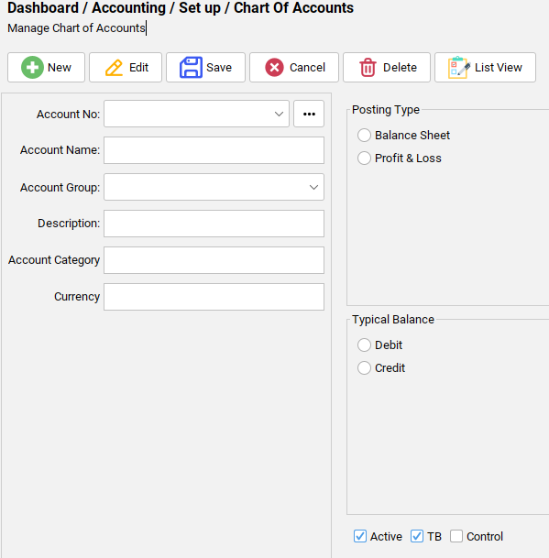

* Create a new account in the **New** button (A form dialog **AR1** pops to allow you add an account)

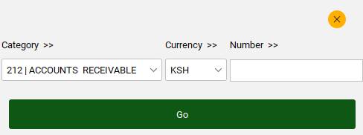

**AR 2**

**AR 3**

**AR 1**

* Add the category in which you want your account to be from the dropdown **AR2**
* Enter number **AR3** it includes only 3digit number to mark your account
* Click on **Go** button to save

After saving the detail account should display as shown;

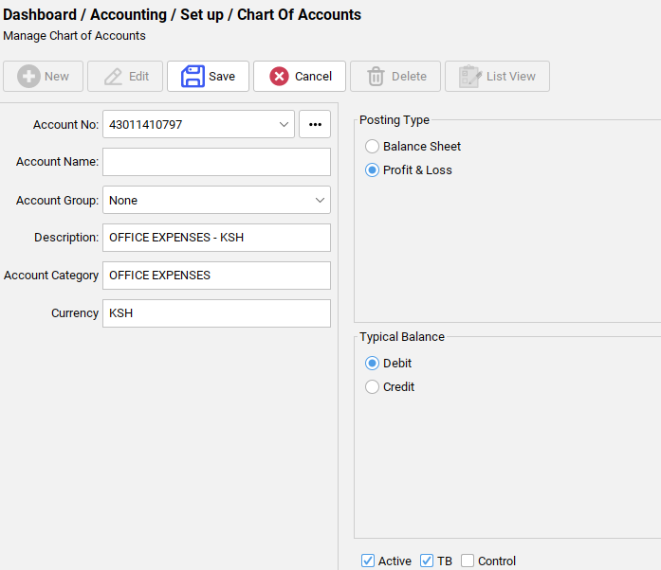

**AR 1**

**AR 2**

**AR 3**

**AR 4**

* Posting type **AR1** and Typical balance **AR2** should auto fill depending on the account you want to create
* Enter the account name **AR3** the name of the account you want to create

The rest of the fields autofill when creating new account

* Proceed to save button **AR4** to save the account or click cancel button to cancel the account

**>>>Under List view**

In this section the new account created is saved here and all other accounts created



**AR 1**

* Click list view **AR1**(A form pops showing all the accounts created as shown below;)

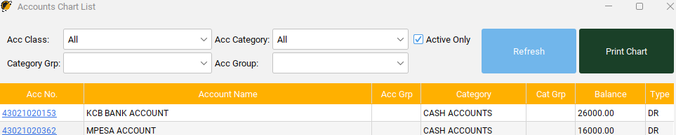

**AR 2**

* Under Acc class **AR2** you can filter the data in the table by Assets, Expenses, Income or Liabilities

**>>>Under Assets**

This section contains all cash accounts and the amount of money in each account (assets put money in) and account receivables etc.

**>>>Under Expenses**

Contain all expenses incurred in the church either paying suppliers, purchasing something for the church any money spent to get something.

**>>>Under Income**

This contain all accounts that originate from any income in the church what the church is gaining e.g. Offertory, tithes, pledges, donations to the church etc.

**>>>Under liabilities**

Accounts of creditors, loans or capital is included.

**>>>Under total**

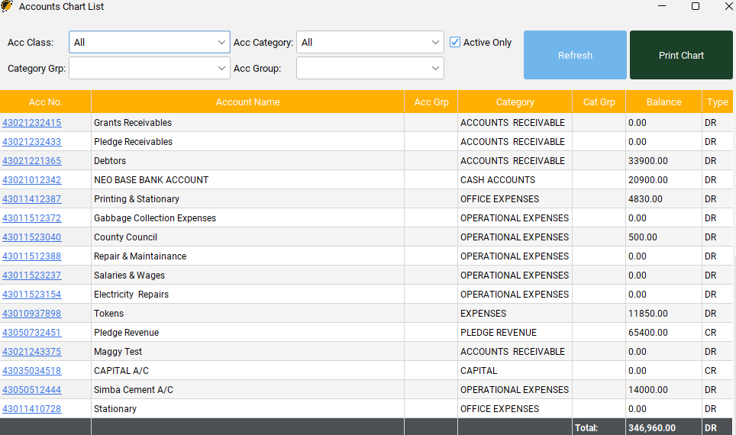

**AR 3**

* Total **AR3** total amount balance of money in all account created is added here.

### Financial Periods

## Transactions

### Post Transactions

This section records all transactions made in the church, be it expenses, budgeting, project pledges, debtors all of these transactions are recorded here, each time you post a transaction its recorded in this transaction table.

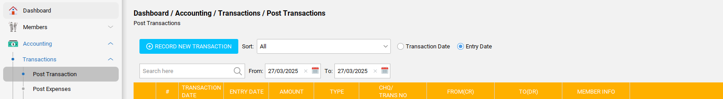

**AR 7**

**AR 2 2**

**AR 5**

**AR 6**

**AR 3**

**AR 4**

* Click post transactions **AR2**
* Proceed to Dashboard/accounting/transaction….
* Under Transaction date **AR3** enters the current transactions date the day the transaction was made
* Under Entry date **AR4** enters the date you record a previous transactions made
* **AR5** and **AR6** automatically reflects all transactions from day one to the last transaction

Once you click AR3 the following proceeds;

* Click record new transactions **AR7**(A dialog **AR8** is created to allow transactions to be recorded)

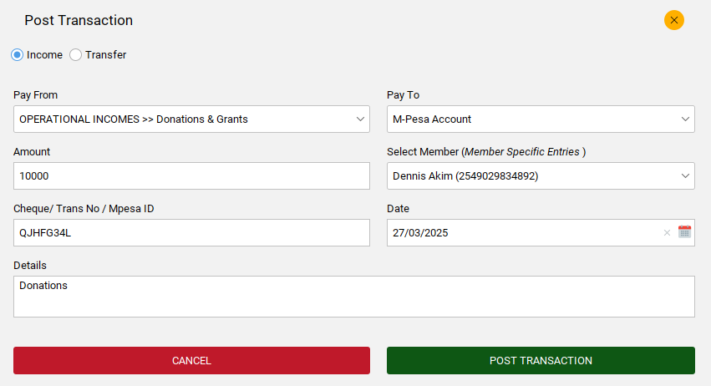

**AR 8**

**AR 9**

**AR 10**

**AR 12**

**AR 11**

**AR 14**

**AR 13**

**AR 15**

**AR 16**

**AR 17**

**AR 18**

* Click **AR9** to record the transaction as income
* Click pay from **AR10**(choose from the dropdown this includes the accounts created)
* Enter Pay to **AR11** choose the cash book account to pay the money to
* Enter amount **AR12**
* Select member **AR113** who did the transaction
* Enter the mpesaID or transaction number or a cheque **AR14**
* Enter the date the transaction was made **AR15**
* Under details **AR16** record anything about the transaction or what it was for
* Click post transaction **AR17** to save or click cancel button **AR18** to cancel it

After saving the transaction details should be saved as shown below;

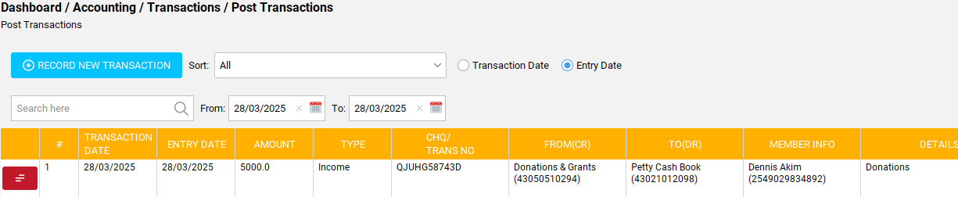

**>>>To transfer a money from one account to another;**

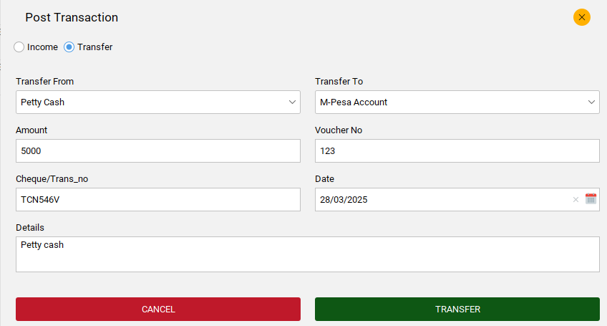

**AR 1**

**AR 2**

**AR 3**

**AR 4**

**AR 5**

**AR 6**

**AR 7**

**AR 8**

* Click transfer **AR1**
* Enter account you want to transfer money from **AR2**
* Enter the account you want to transfer money to **AR3**
* Enter the amount you want to transfer **AR4**
* Enter voucher number **AR5**
* Enter the transaction id or mpesa code **AR6**
* Enter the date **AR7**
* Enter details a short description **AR8**
* Click **TRANSFER** to transfer funds and **CANCEL** to cancel the transfer

### Post expenses

This section allows you to post all the expenses incurred be operational expenses, overall expenses or office expenses.

The expenses originate from the accounts created under charts of accounts. You can add all or few expense as you like in AR1

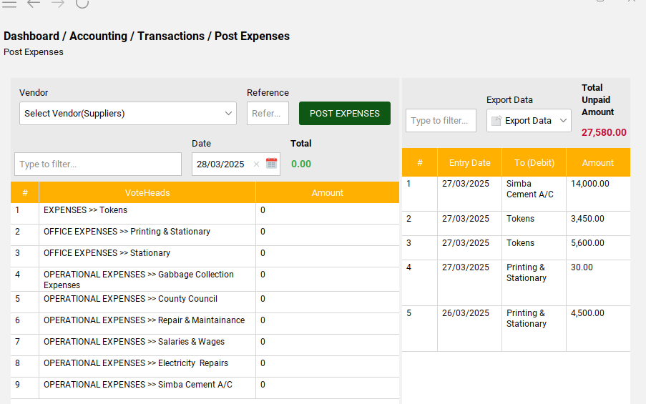

**AR 1**

To post an expense;

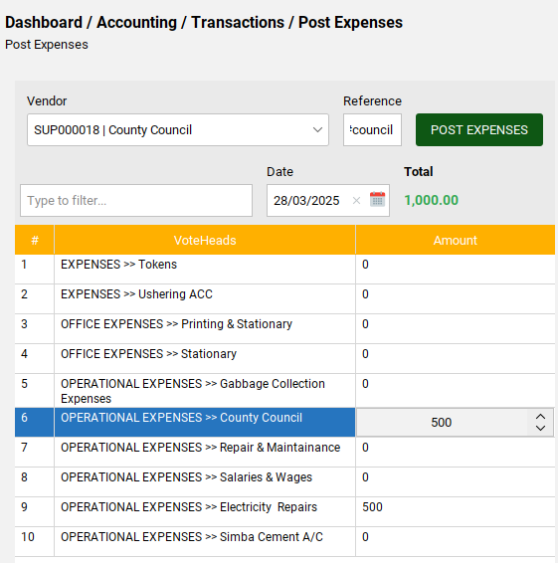

**AR 4**

**AR 2**

**AR 3**

**AR 5**

* Click **AR1** and enter the amount to post
* Under vendor **AR2** select the supplier of the expense you are posting
* Add reference **AR3** can be short vendor description or code
* Click post expenses **AR4**
* Under total **AR5** automatically reflects the total amount of expenses you are posting

After posting the expenses they should record on the right in the table as shown in **AR6**;

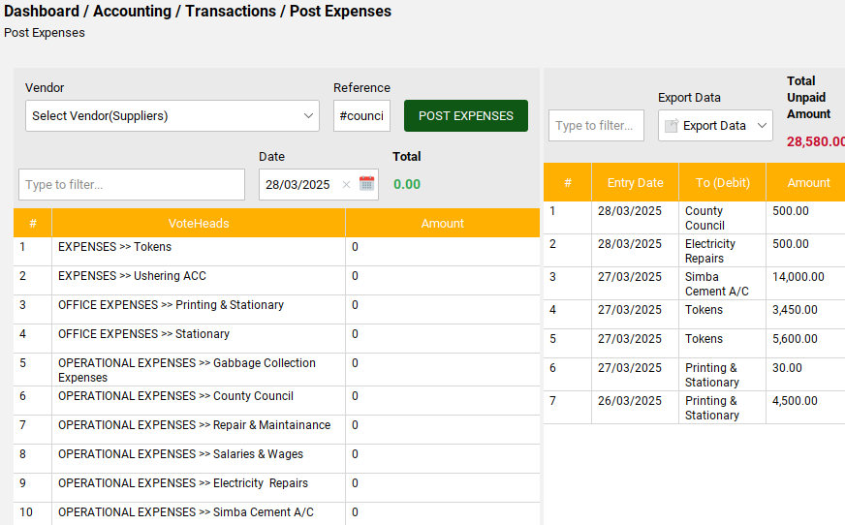

**AR 6**

This part records all the expenses you post and they are recorded as Unpaid. To pay the expenses posted, navigate to the next part of Pay expenses.

### Pay Expenses

This section its where we make payments of the expenses posted in the previous task.

Under the pay expenses shown below, contain all expenses posted the amount of all expenses is recorded as Unpaid **AR1**

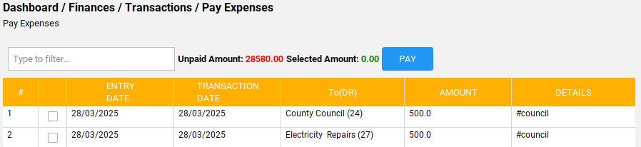

**AR 1**

To proceed in paying the expenses;

* Select or tick the expenses to pay as shown **AR2**

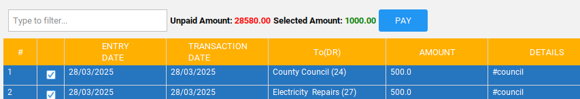

**AR 2**

**AR 3**

**AR 4**

As you select the expenses to pay, the total amount should reflect under selected amount **AR3**

* Click pay **AR4**(A form dialog pops to confirm payment)

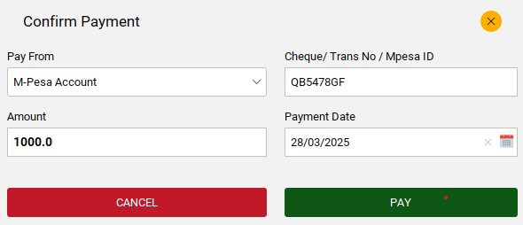

**AR 5**

**AR 6**

* Choose the account where you want to get the money to pay the expenses from **AR5**
* Enter transaction No **AR6**
* In the amount it reflects automatically
* Enter payment date
* Click pay button to **PAY** or cancel to **CANCEL** the payment

***NB: Once you make payments the expenses paid should be excluded from the pay expenses table***

### Expenses data

This section records all the posted expenses and paid expenses. It includes the total amount of money all expenses have.

* You can export data of all the expenses in excel or PDF **AR1**
* You can sort the data **AR2** by PAID expenses or UNPAID expenses
* You can filter expense data from the oldest expenses record or the latest expenses

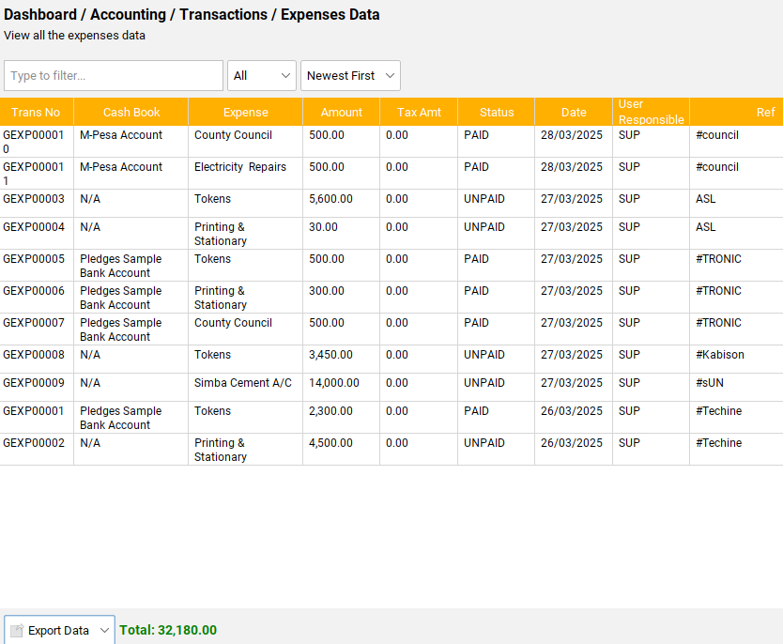

**AR 1**

**AR 2**

**AR 3**

## 3. Givings (Collections)

This section manages the project pledges, invoices creation and individual collections from members or visitors or any other person willing to contribute to the church fundings.

### Pledges

This is where church projects and pledges are recorded. Every member or anyone who pledges an invoice is created here.

>>>Once you click on pledges it takes you to **AR1**

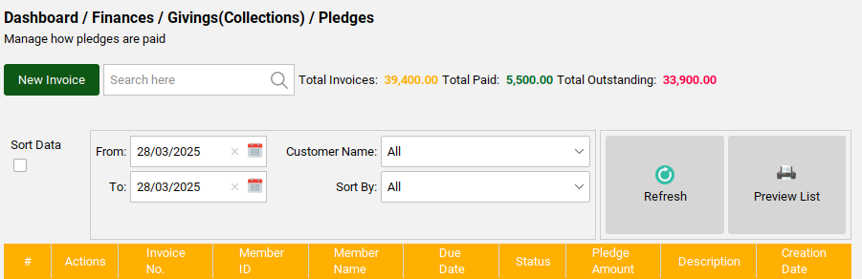

**AR 1**

**AR 2**

* Click New invoice **AR2** to create an invoice pledge
* A form dialog **AR3** you to record pledges

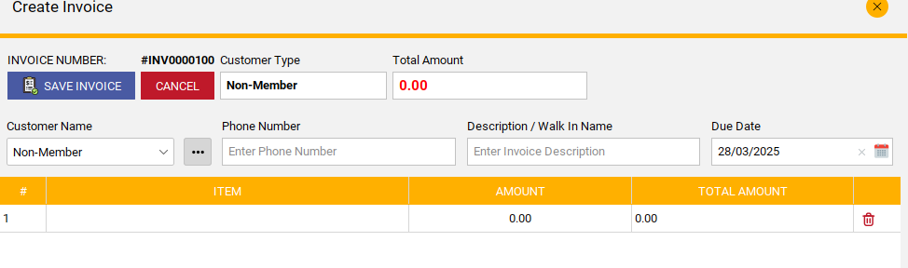

**AR 3**

**AR 5**

**AR 4**

**AR 6**

**AR 7**

**AR 8**

* Click **AR4** to add the project name enter **AMOUNT**
* Add a customer name **AR5** it can be a non-member or click on the Three dots to add a member name who wants to pledge as shown below;

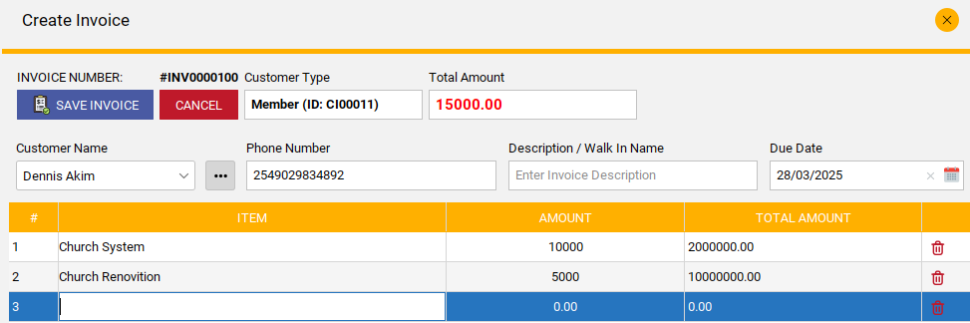

>>>Once you select a member the member details fill including invoice number, phone number and member ID.

* Add a description **AR7** can be a name
* Enter date **AR8**
* Click SAVEINVOICE

>>> Once the invoice is saved it appears **DRAFT** meaning it is yet to be confirmed or paid as shown below; It also show the total amount of money pledged by that member.

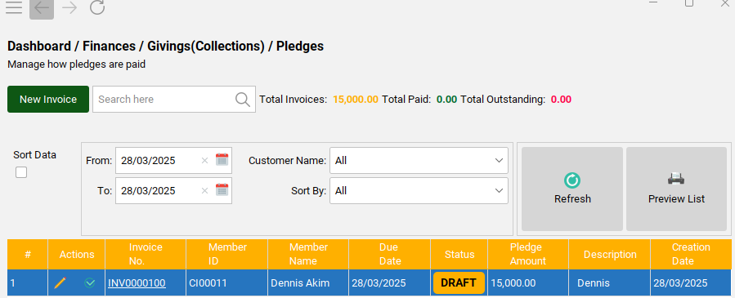

**AR 2**

>>>To be able to confirm the invoice;

* Click tick icon **AR2**
* A dialog form **AR3** pops showing the project pledged by the member to enable invoice confirmation

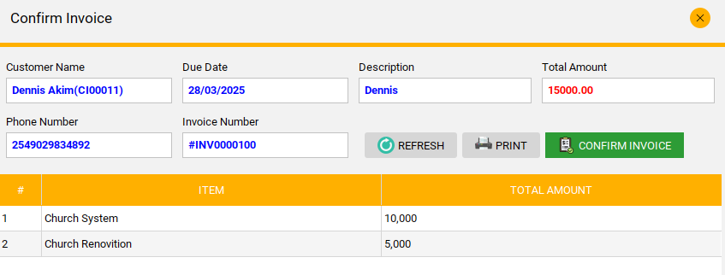

**AR 3**

* Click **CONFIRM INVOICE**

>>>Once the invoice is confirmed it changes state to **OPEN** as shown below;

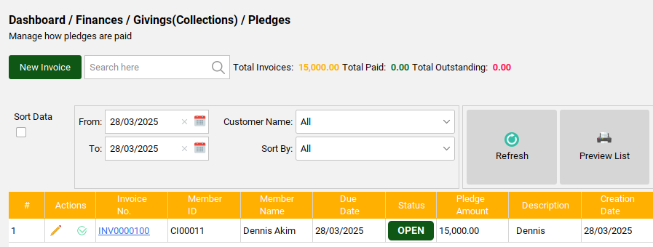

**AR 1**

***NB****:* ***All invoices with an OPEN state cannot be edited.***

>>>Open invoice gives you an opportunity to be able to make payment or deposit the amount pledges owned.

>>>To make payment;

* Click tick icon **AR1**(A form dialog **AR2** opens to allow payment)

**AR 2**

**AR 3**

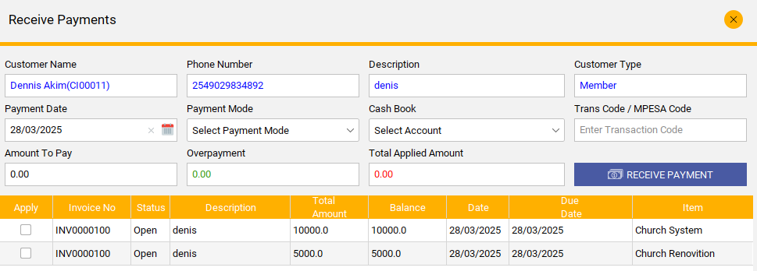

* Select the **Payment Mode**
* In **Cash Book** enter the account to pay from
* Enter **mpesa Code**
* Enter **Amount to Pay**
* Click **AR3** to choose the project you want to pay (a form pop to confirm payment as shown)

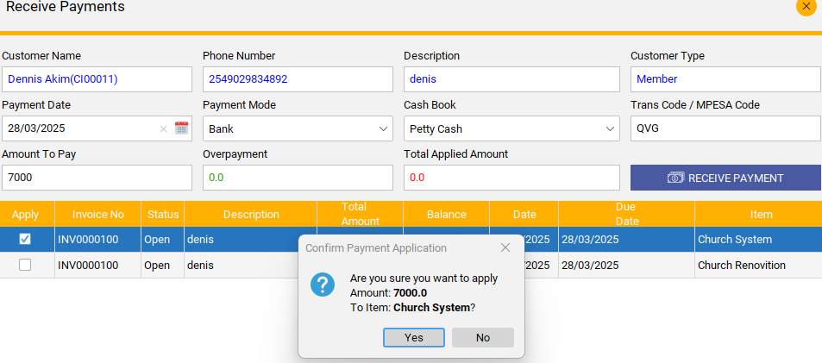

* Click yes to accept or no to go back
* Click **RECEIVE PAYMENT** and confirm as shown;

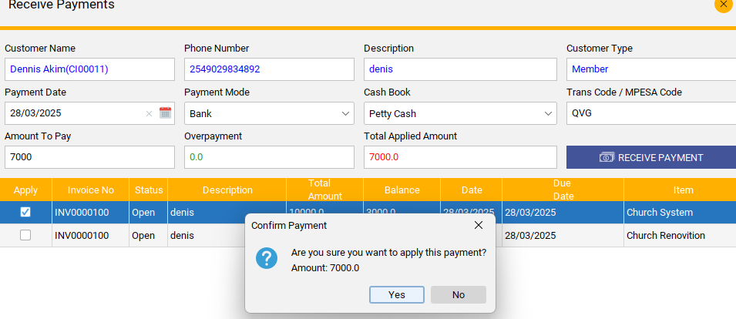

>>>When a member pays all her debts in the pledges the invoice status changed to **CLOSED** this means that the member has completed his pay and can decide to make new pledges.

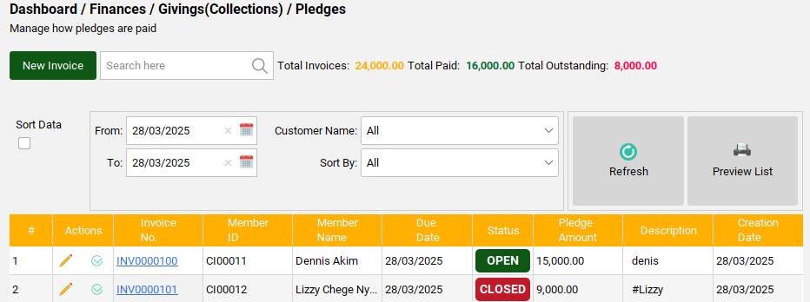

**AR 1**

>>>To be able to view a member summary detail of all his pledges and how its paid

* Click column Invoice number in the member **AR1** to display the following dialog **AR2** statement

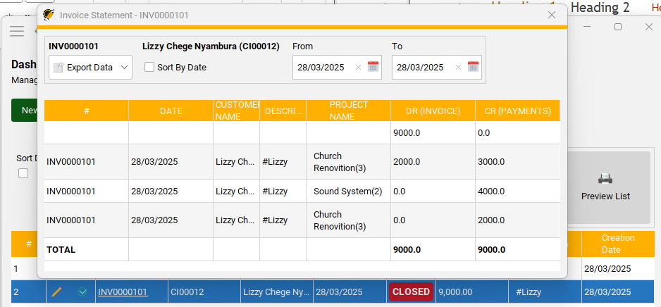

AR 2

# CHAPTER: Support

## Contact Support

This section holds information about the developers of the system, how to reach them, their social websites and the kind of work they offer

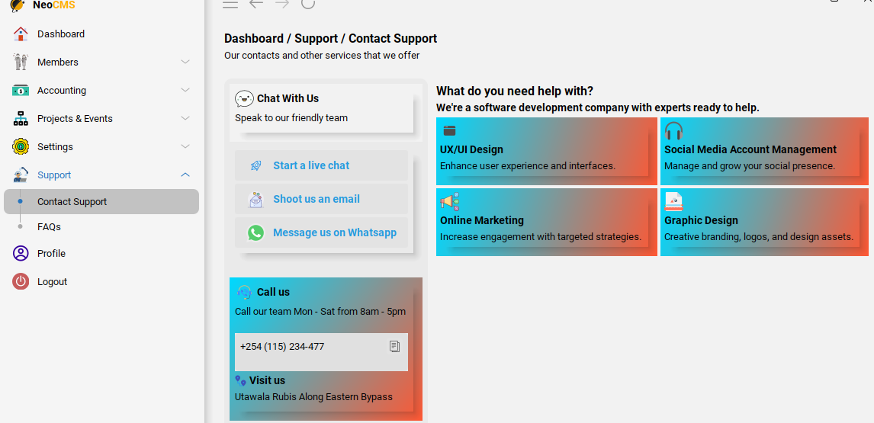

## FAQs

This section entails frequent asked questions or common questions and answers to provide the user with quick information.

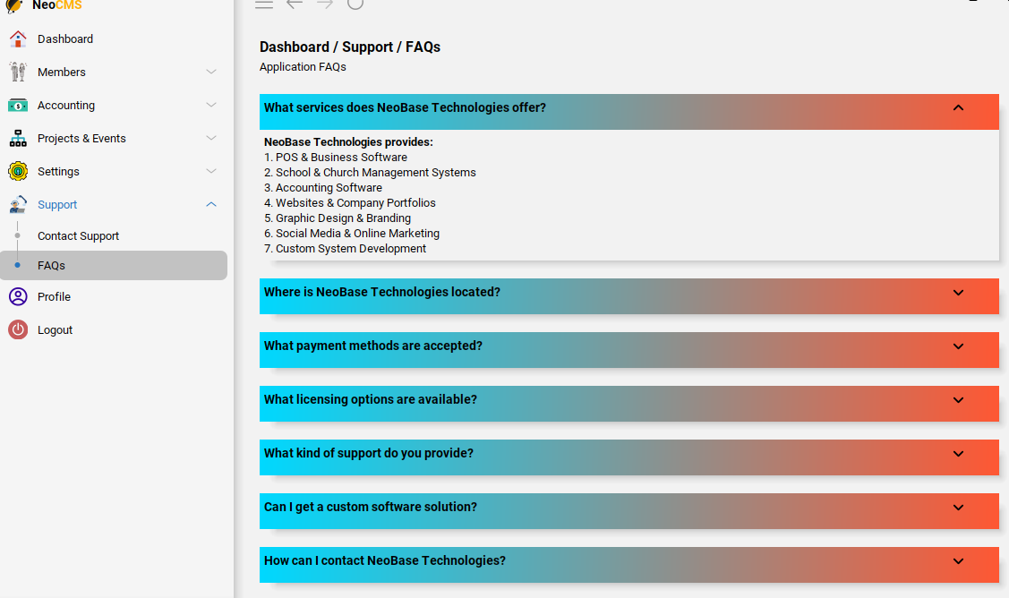

# CHAPTER: Profile

## Profile creation

As an admin accessing the system one can create or change their login profile as shown;

* Click on profile

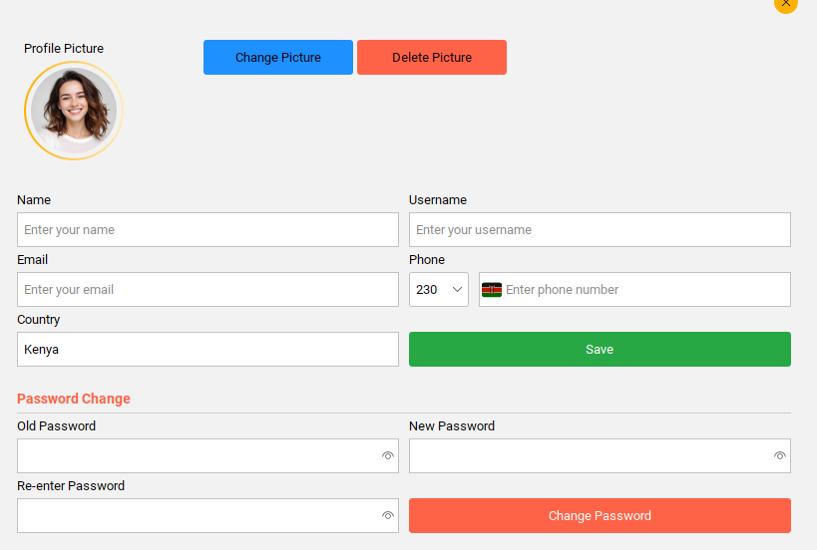

* Enter the name
* Enter email
* Enter country
* Enter username
* Enter phone number
* Click **Save** button

**>>>To change picture**

* Click Change Picture button

**>>>To delete a picture**

* Click Delete Picture button

**>>>To change password**

* Enter old password
* Enter new password
* Re-enter password
* Click Change Password button